Spring Web MVC 2
Introduction 2
The DispatcherServlet 2
Request Mapping at class & Method level 4
MutliAction Controller 4
@PathVariable 4
Binding request parameters to method parameters with @RequestParam 5
@ModelAttribute Annotation at method argument 5
@ModelAttribute Annotation at method level 6
Handle Validation Error 6
Customizing data binding with @InitBinder 6
Write own Custom Property Editor 7
Form Validation using Hibernate Validators 7
Form Validation with customize error messages using Spring MessageSource 7
Replace hard coded values with Placeholders 8
Form Validation with @Pattern, @Past, @Max 8
Create own Custom Form Validation annotation 8
Interceptor 9
Store data into Session Object 9
Manage Contact details Application 10

Spring Web MVC

Introduction
Spring MVC, a Java Model-View-Controller (MVC) web framework, which builds on the Spring Inversion of control(IoC) framework, extensive use of the Spring’s features make the Spring MVC framework highly decouple the components dependency and simplify the whole MVC configuration.

The Spring Web model-view-controller (MVC) framework is designed around a DispatcherServlet that dispatches requests to handlers, with configurable handler mappings, view resolution, locale, time zone and theme resolution as well as support for uploading files.

The default handler is based on the @Controller (No need to extend AbstractController OR SimpleFormController) and @RequestMapping annotations (No more declaration for the handler mapping like BeanNameUrlHandlerMapping, ControllerClassNameHandlerMapping or SimpleUrlHandlerMapping), offering a wide range of flexible handling methods.

The DispatcherServlet
Spring’s web MVC framework is, like many other web MVC frameworks, request-driven, designed around a central Servlet that dispatches requests to controllers and offers other functionality that facilitates the development of web applications.

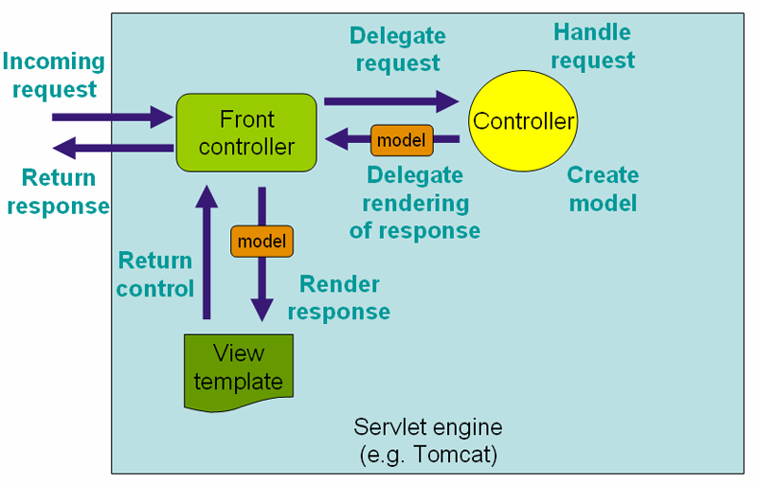
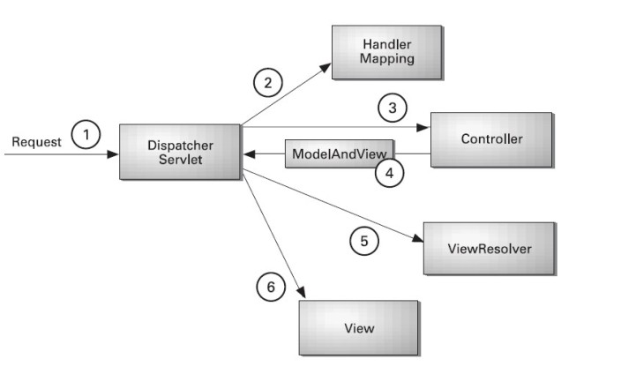

The DispatcherServlet is an actual Servlet (it inherits from the HttpServlet base class), and as such is declared in the web.xml of our web application. We need to map requests that you want the DispatcherServlet to handle, by using a URL mapping in the same web.xml file. This is standard Java EE Servlet configuration; the following example shows such a DispatcherServlet declaration and mapping:
<web-app>
<servlet>
<servlet-name>example</servlet-name>
<servlet-class>org.springframework.web.servlet.DispatcherServlet</servlet-class>
<load-on-startup>1</load-on-startup>
</servlet>

<servlet-mapping>
<servlet-name>example</servlet-name>
<url-pattern>/example/*</url-pattern>
</servlet-mapping>
</web-app>

In a Servlet 3.0+ environment, you also have the option of configuring the Servlet container programmatically.
public class MyWebApplicationInitializer implements WebApplicationInitializer {

@Override
public void onStartup(ServletContext container) {
ServletRegistration.Dynamic registration = container.addServlet("dispatcher", new DispatcherServlet());
registration.setLoadOnStartup(1);
registration.addMapping("/example/*");
}
}

Upon initialization of a DispatcherServlet, Spring MVC looks for a file named example-servlet.xml in the WEB-INF directory of your web application and creates the beans defined there, overriding the definitions of any beans defined with the same name in the global scope.

Request Mapping at class & Method level
Example- Hello World Application
com.gps.spring.mvc.controller.HelloWorldController.java
web.xml, helloPage.jsp, contact-servlet.xml
http://localhost:8080/ContactApp/greet => Request not available
http://localhost:8080/ContactApp/welcome => Request not available
http://localhost:8080/ContactApp/greet/welcome
http://localhost:8080/ContactApp/greet/hi

MutliAction Controller
If we want to define Single Controller for multiple similar types of actions then apply concept of MutliAction Controller.
@RequestMapping annotation is used to map a particular HTTP request method (GET/POST) to a specific class/method in controller which will handle the respective request.
@RequestMapping annotation can be applied both at class and method level. In class level we can map the URL of the request and in method we can map the url as well as HTTP request method (GET/POST).

In a multi-action controller urls are mapped at method level since the controller services multiple urls.

@Controller
@RequestMapping("/appointments")
public class AppointmentsController {

private final AppointmentBook appointmentBook;

@Autowired
public AppointmentsController(AppointmentBook appointmentBook) {
this.appointmentBook = appointmentBook;
}

@RequestMapping(method = RequestMethod.GET)
public Map<String, Appointment> get() {
return appointmentBook.getAppointmentsForToday();
}

@RequestMapping(value="/new", method = RequestMethod.GET)
public AppointmentForm getNewForm() {
return new AppointmentForm();
}

@RequestMapping(method = RequestMethod.POST)
public String add(@Valid AppointmentForm appointment, BindingResult result) {
if (result.hasErrors()) {
return "appointments/new";
}
appointmentBook.addAppointment(appointment);
return "redirect:/appointments";
}
}
In the example, the @RequestMapping is used in a number of places. The first usage is on the type (class) level, which indicates that all handling methods on this controller are relative to the /appointments path. The get() method has a further @RequestMapping refinement: it only accepts GET requests, meaning that an HTTP GET for /appointments invokes this method. The add() has a similar refinement, and the getNewForm() combines the definition of HTTP method and path into one, so that GET requests for appointments/new are handled by that method.

@PathVariable
In Spring MVC you can use the @PathVariable annotation on a method argument to bind it to the value of a URI template variable.
@RequestMapping(value = "/welcome/{userName}/{password}/{org}")
public ModelAndView getAllUriTemplateVariable(@PathVariable Map<String, String> pathVars) {
ModelAndView model = new ModelAndView("helloPage");
String param = "Username [" + pathVars.get("userName") + "]\n";
param += "Password [" + pathVars.get("password") + "]\n";
param += "Organization [" + pathVars.get("org") + "]";

model.addObject("msg", "Hi How are you..." + param);
return model;
}

Example- Hello World Application
com.gps.spring.mvc.controller.HelloWorldController.java
web.xml, helloPage.jsp, contact-servlet.xml

<mvc:annotation-driven />

http://localhost:8080/ContactApp/greet/welcome/gpsgroup/pass
http://localhost:8080/ContactApp/greet/welcome/a/b/c

Binding request parameters to method parameters with @RequestParam
Use the @RequestParam annotation to bind request parameters to a method parameter in your controller. We can provide default value for the parameter. We can also use “@RequestParam Map<String, String> params” to access all parameters using <mvc:annotation-driven />
.

@RequestMapping(value = "/submitUserRegistrationForm", method = RequestMethod.POST)
public ModelAndView submitUserRegisterationForm(
@RequestParam(value = "userName", defaultValue = "AmitGPS") String uName,
@RequestParam(value = "emailId") String email, @RequestParam("password") String pass) {
ModelAndView model = new ModelAndView("userRegisterationSuccess");

model.addObject("userName", uName);
model.addObject("msg", "Details are [" + email + " ----" + pass + "]");
return model;
}

Example- New User Registration Application
com.gps.spring.mvc.controller.UserRegistrationController.java
web.xml, userRegisterationForm.jsp, userRegisterationSuccess.jsp,
contact-servlet.xml

http://localhost:8080/ContactApp/userRegisterationForm.html
http://localhost:8080/ContactApp/userRegisterationForm

@ModelAttribute Annotation at method argument
The @ModelAttribute annotation can be used on methods or on method arguments.
A @ModelAttribute on a method argument indicates the argument should be retrieved from the model. If not present in the model, the argument should be instantiated first and then added to the model. Once present in the model, the argument’s fields should be populated from all request parameters that have matching names. This is known as data binding in Spring MVC, a very useful mechanism that saves you from having to parse each form field individually.
Inbuilt OR user defined data Type Auto data conversion provided by spring MVC via auto data binding feature.

Example-
- Store new user registration form into a Model “User” without using @ModelAttribute
com.gps.spring.mvc.model.User.java com.gps.spring.mvc.controller.NewUserRegistrationController.java
newUserRegisterationForm.jsp, newUserRegisterationSuccess.jsp
http://localhost:8080/ContactApp/newUserRegisterationForm

- Store new user registration form into a Model “User” using @ModelAttribute
com.gps.spring.mvc.model.User.java com.gps.spring.mvc.controller.NewUserRegistrationController.java
newUserRegisterationForm.jsp, newUserRegisterationSuccess.jsp

http://localhost:8080/ContactApp/newUserRegisterationForm

@ModelAttribute Annotation at method level
The @ModelAttribute on a method indicates the purpose of that method is to add one or more model attributes. Such methods support the same argument types as @RequestMapping methods but cannot be mapped directly to requests. Instead @ModelAttribute methods in a controller are invoked before @RequestMapping methods, within the same controller.

Example- Add common object to Model when any of the controller method get called
com.gps.spring.mvc.model.User.java com.gps.spring.mvc.controller.NewUserRegistrationController.java
newUserRegisterationForm.jsp, newUserRegisterationSuccess.jsp

http://localhost:8080/ContactApp/newUserRegisterationForm

Handle Validation Error
Using BindingResult class inside controller & spring’s <form:errors> tag we can easily handle data mismatched OR data binding related errors.
Example- If we provide string instead of number inside phone field OR any string instead of date format inside dob field
com.gps.spring.mvc.model.User.java com.gps.spring.mvc.controller.NewUserRegistrationController.java
newUserRegisterationForm.jsp, newUserRegisterationSuccess.jsp

http://localhost:8080/ContactApp/newUserRegisterationForm

Customizing data binding with @InitBinder
Annotating controller methods with @InitBinder allows you to configure web data binding directly within your controller class. @InitBinder identifies methods that initialize the WebDataBinder that will be used to populate command and form object arguments of annotated handler methods.

Spring uses the concept of PropertyEditors to effect the conversion between an Object and a String. If we think about it, it sometimes might be handy to be able to represent properties in a different way than the object itself. For example, a Date can be represented in a human readable way (as the String ' 2007-14-09'), while we’re still able to convert the human readable form back to the original date (or even better: convert any date entered in a human readable form, back to Date objects). This behaviour can be achieved by registering custom editors, of type java.beans.PropertyEditor.

PropertyEditor is custom classes like CustomDateEditor OR FileEditor OR CustomBooleanEditor OR CustomNumberEditor OR ClassEditor OR URLEditor etc which help to customize data binding for a particular data type.

Example- Let’s suppose we want to exclude phone field during data binding OR apply specific date format should be entered inside dob field.
com.gps.spring.mvc.model.User.java com.gps.spring.mvc.controller.NewUserRegistrationController.java
newUserRegisterationForm.jsp, newUserRegisterationSuccess.jsp

http://localhost:8080/ContactApp/newUserRegisterationForm

Write own Custom Property Editor
Let’s suppose our requirement is – User must provide Gender specific initials (Mr. / Ms.) followed by username inside User’s Name field then only user data with bind to model. If user missed it then by default Ms. will be applied.

Example-
com.gps.spring.mvc.custom.UserNameEditor.java
com.gps.spring.mvc.model.User.java com.gps.spring.mvc.controller.NewUserRegistrationController.java
newUserRegisterationForm.jsp, newUserRegisterationSuccess.jsp

http://localhost:8080/ContactApp/newUserRegisterationForm

Form Validation using Hibernate Validators
Beginning with Spring 3, Spring MVC has the ability to automatically validate @Controller inputs. In previous versions it was up to the developer to manually invoke validation logic.
To trigger validation of a @Controller input, simply annotate the input argument as @Valid.
Spring MVC will validate a @Valid object after binding so-long as an appropriate Validator has been configured.

Note: The @Valid annotation is part of the standard JSR-303 Bean Validation API, and is not a Spring-specific construct.

Add dependency of Hibernate validator into pom.xml
<dependency>
<groupId>org.hibernate</groupId>
<artifactId>hibernate-validator</artifactId>
<version>5.2.0.CR1</version>
</dependency>

Example- Length of email Id should be min = 5 & max = 10
com.gps.spring.mvc.model.User.java com.gps.spring.mvc.controller.NewUserRegistrationController.java
newUserRegisterationForm.jsp, newUserRegisterationSuccess.jsp

http://localhost:8080/ContactApp/newUserRegisterationForm

Form Validation with customize error messages using Spring MessageSource
- @Size(min = 5, max = 10, message = "Length of email Id should be >={min} & <={max}")

- Property of message inside Resource bundle should follow below format:
[Validation Annotation name].[Object reference name].[Field name]
e.g. Size.user.emailId=Size of email Id should be >=5 & <=10

Example- Length of email Id should be min = 5 & max = 10
com.gps.spring.mvc.model.User.java
src/main/resources/messages_en.properties
com.gps.spring.mvc.controller.NewUserRegistrationController.java
newUserRegisterationForm.jsp, newUserRegisterationSuccess.jsp

http://localhost:8080/ContactApp/newUserRegisterationForm

Replace hard coded values with Placeholders
{0} with Field name
{2} with 1st parameter i.e. min
{1} with 2nd parameter i.e. max
e.g. Size.user.emailId=Size of {0} should be >={2} & <={1}

Example- Length of email Id should be min = 5 & max = 10
com.gps.spring.mvc.model.User.java
src/main/resources/messages_en.properties
com.gps.spring.mvc.controller.NewUserRegistrationController.java
newUserRegisterationForm.jsp, newUserRegisterationSuccess.jsp

http://localhost:8080/ContactApp/newUserRegisterationForm

Form Validation with @Pattern, @Past, @Max

Example- Number not allowed with username
@Pattern(regexp="\\D*", message="Invalid username. Number not allowed.")
private String userName;

Example- DOB not greater than today’s date
@Past(message="DOB can't be greater than today's date")
private Date dob;

Example- Length of email Id should be min = 5 & max = 10
com.gps.spring.mvc.model.User.java
src/main/resources/messages_en.properties
com.gps.spring.mvc.controller.NewUserRegistrationController.java
newUserRegisterationForm.jsp, newUserRegisterationSuccess.jsp

http://localhost:8080/ContactApp/newUserRegisterationForm

Few more validation based annotations are-
@Future – Checks whether the annotation date is in the future
@Min - <=
@Max - >=
@NotNull
@NotEmpty – Check the string is not null & not empty

Create own Custom Form Validation annotation
1. Create a Java file (annotation) – having complete definition of custom annotation like name of custom annotation, the default error message information, etc.

2. Create a Java file – having the validation logic used by above custom annotation to validate the user input

Example- User can provides any of the city – {Delhi / Noida / Gurgaon / Banglore /
Mumbai}
com.gps.spring.mvc.custom.IsValidCity.java
com.gps.spring.mvc.custom.CityValidator.java
com.gps.spring.mvc.model.User.java
com.gps.spring.mvc.controller.NewUserRegistrationController.java
newUserRegisterationForm.jsp, newUserRegisterationSuccess.jsp

http://localhost:8080/ContactApp/newUserRegisterationForm

Interceptor
Spring’s handler mapping mechanism includes handler interceptors, which are useful when you want to apply specific functionality to certain requests, for example, checking for a principal.
Interceptors located in the handler mapping must implement HandlerInterceptor from the org.springframework.web.servlet package. This interface defines three methods: preHandle(..) is called before the actual handler is executed; postHandle(..) is called after the handler is executed; and afterCompletion(..) is called after the complete request has finished. These three methods should provide enough flexibility to do all kinds of preprocessing and postprocessing.
Steps to instruct Spring MVC to perform some task before handling a request-
- Include a Java class which extends HandlerInterceptorAdaptor class & override one of its method with the name preHandle
- Put an entry of this class in the Spring configuration file
<mvc:interceptors>
<bean class = "com.gps.spring.mvc.controller.DayOfWeekBasedAccessInterceptor"/>
</mvc:interceptors>
OR
<mvc:interceptors>
<mvc:interceptor>
<mvc:mapping path=”/newUserRegisterationForm” />
<bean class = "com.gps.spring.mvc.controller.DayOfWeekBasedAccessInterceptor"/>
</mvc:interceptor>
</mvc:interceptors>

Example- When user access our website on Sunday, Let’s us suppose we want to display a message “The Website does not work on Sunday; Please try accessing it on any other week day.”
com.gps.spring.mvc.controller.DayOfWeekBasedAccessInterceptor.java
contact-servlet.xml

http://localhost:8080/ContactApp/newUserRegisterationForm

Store data into Session Object
We can use any one of the below 3 ways-
- By using @SessionAttributes we can handle session into Spring at Controller.
For example-
@Controller

@SessionAttributes("thought")

public class SingleFieldController {

@RequestMapping(value="/single-field")

public ModelAndView singleFieldPage() {

return new ModelAndView("single-field-page");

}

@RequestMapping(value="/remember")

public ModelAndView rememberThought(@RequestParam String thoughtParam) {

ModelAndView modelAndView = new ModelAndView();

modelAndView.addObject("thought", thoughtParam);

modelAndView.setViewName("single-field-page");

return modelAndView;

}

}

- Just inject in HttpSession where it is required.
@Autowired
private HttpSession httpSession;

- Accept it as a parameter, this will work only in the web tier though:
@Controller
public class ShoppingCartController {

@RequestMapping("/addToCart")
public String addToCart(long productId, HttpSession httpSession) {
//do something with the httpSession
}

}

Manage Contact details Application
Example- Add, Delete & Display all contacts
com.gps.spring.mvc.controller.ContactController.java
com.gps.spring.mvc.service: ContactService & ContactServiceImpl.java
com.gps.spring.mvc.dao: ContactDao & ContactDaoImpl.java
com.gps.spring.mvc.model.Contact.java
web.xml, contact-servlet.xml
index.jsp, contact.jsp
jdbc.properties, messages_en.properties, log4j.properties

http://localhost:8080/ContactApp/

